Esophageal Cancer

**In Barrett’s esophagus, tissue in the tube connecting your mouth and stomach (esophagus) is replaced by tissue similar to the intestinal lining.**

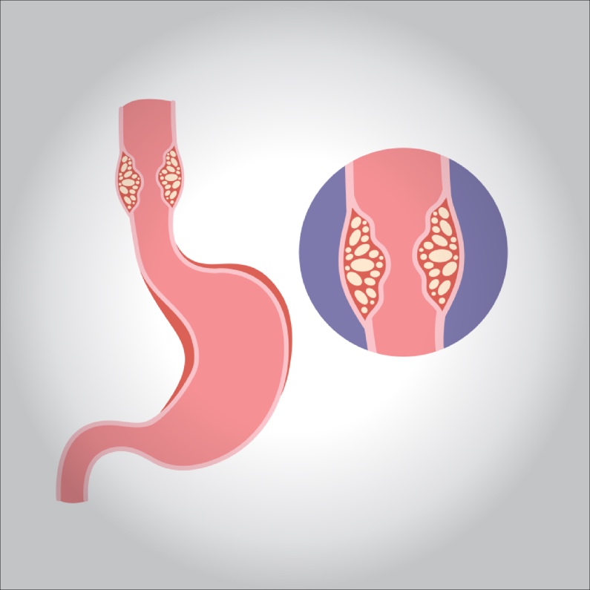

**Barrett’s esophagus is often diagnosed in people who have long-term gastroesophageal reflux disease (GERD) — a chronic regurgitation of acid from the stomach into the lower esophagus. Only a small percentage of people with GERD will develop Barrett’s esophagus.**

**Barrett’s esophagus is associated with an increased risk of developing esophageal cancer. Although the risk is small, it’s important to have regular checkups for precancerous cells (dysplasia). If precancerous cells are discovered, they can be treated to prevent esophageal cancer.**

**Symptoms**

**The tissue changes that characterize Barrett’s esophagus cause no symptoms. The signs and symptoms that you experience are generally due to GERD and may include:**

* **Frequent heartburn**
* **Difficulty swallowing food**
* **Less commonly, chest pain**

**Many people with Barrett’s esophagus have no signs or symptoms.**

**Causes**

**The exact cause of Barrett’s esophagus isn’t known. Most people with Barrett’s esophagus have long-standing GERD.**

**In GERD, stomach contents wash back into the esophagus, damaging esophagus tissue. As the esophagus tries to heal itself, the cells can change to the type of cells found in Barrett’s esophagus.**

**However, some people diagnosed with Barrett’s esophagus have never experienced heartburn or acid reflux. It’s not clear what causes Barrett’s esophagus in these people.**

**Risk factors**

**Factors that increase your risk of Barrett’s esophagus include:**

* **Chronic heartburn and acid reflux. Having GERD that doesn’t get better when taking medications known as proton pump inhibitors or having GERD that requires regular medication can increase the risk of Barrett’s esophagus.**
* **Age. Barrett’s esophagus can occur at any age but is more common in older adults.**
* **Being a man. Men are far more likely to develop Barrett’s esophagus.**
* **Being white. White people have a greater risk of the disease than do people of other races.**
* **Being overweight. Body fat around your abdomen further increases your risk.**
* **Current or past smoking.**

**Treatment**

**Treatment for Barrett’s esophagus depends on the extent of abnormal cell growth in your esophagus and your overall health.**

**In case of “no dysplasia”**

**Your doctor will likely recommend:**

* **Periodic endoscopy to monitor the cells in your esophagus. If your biopsies show no dysplasia, you’ll probably have a follow-up endoscopy in one year and then every three years if no changes occur.**
* **Treatment for GERD. Medication and lifestyle changes can ease your signs and symptoms. Surgery to tighten the sphincter that controls the flow of stomach acid may be an option. Treating GERD doesn’t treat the underlying Barrett’s esophagus and likely won’t decrease the risk of esophageal cancer, but can help make it easier to detect dysplasia.**

**In case of “Low-grade dysplasia”**

**If low-grade dysplasia is found, it should be verified by an experienced pathologist. For low-grade dysplasia, your doctor may recommend another endoscopy in six months, with additional follow-up every six to 12 months.**

**But, given the risk of esophageal cancer, treatment may be recommended if the diagnosis is confirmed. Preferred treatments include:**

* **Endoscopic resection, which uses an endoscope to remove damaged cells.**
* **Radiofrequency ablation, which uses heat to remove abnormal esophagus tissue. Radiofrequency ablation may be recommended after endoscopic resection.**

**If significant inflammation of the esophagus is present at initial endoscopy, another endoscopy is performed after you’ve received three to four months of treatment to reduce stomach acid.**

**In case of “High-grade dysplasia”**

**High-grade dysplasia is generally thought to be a precursor to esophageal cancer. For this reason, your doctor may recommend endoscopic resection or radiofrequency ablation. Other options for treatment include:**

* **Cryotherapy, which uses an endoscope to apply a cold liquid or gas to abnormal cells in the esophagus. The cells are allowed to warm up and then are frozen again. The cycle of freezing and thawing damages the abnormal cells.**
* **Photodynamic therapy, which destroys abnormal cells by making them sensitive to light.**
* **Surgery in which the damaged part of your esophagus is removed and the remaining portion is attached to your stomach.**

**Recurrence of Barrett’s esophagus is possible after treatment. Ask your doctor how often you need to come back for follow-up testing. If you have treatment other than surgery to remove abnormal esophageal tissue, your doctor is likely to recommend medication to reduce acid and help your esophagus heal.**